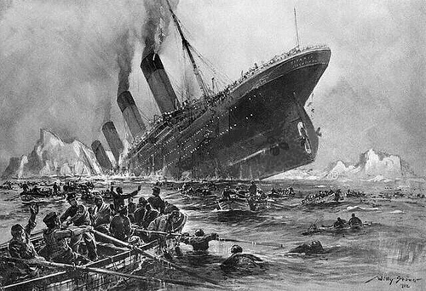

***Titanic Survival Prediction***

**Author**

Alok Sahu

**Introduction**

Hey Folks, in this article, we will be understanding, how to analyse and predict, whether a person, who had boarded the Titanic Ship has a chance of survival or not, using Machine Learning.

**Problem definition**

 The Titanic Problem is based on the sinking of the ‘Unsinkable’ ship Titanic in early 1912. It gives you information about multiple people like their ages, sexes, sibling counts, embarkment points, and whether or not they survived the disaster. Based on these features, you have to predict if an arbitrary passenger on Titanic would survive the sinking or not.

So, we are going to use various Machine Learning Algorithms to check which one is giving us the more accurate outcome.

We are going to follow the following steps:

1.      Data Analysis  
2.      EDA  
3.      Pre-processing Data  
4.      Building Machine Learning Models  
5.     Concluding Remarks

**Data Analysis**

* Before starting the project, we have to import some of the important libraries

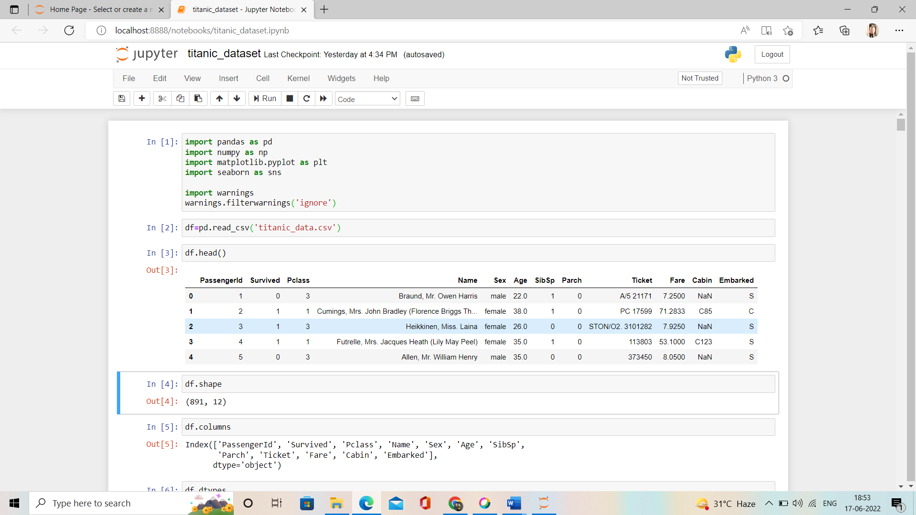

* Data is the most important part of any analysis in any project. How much the prediction is correct is mainly based upon how clean data we have

Let’s see the data we have



* In data we have ages, sexes, sibling counts, embarkment points, Cabin, Passenger, Parch, Ticket, Fare and whether or not they survived the disaster
* Total rows and column we have is



**columns**

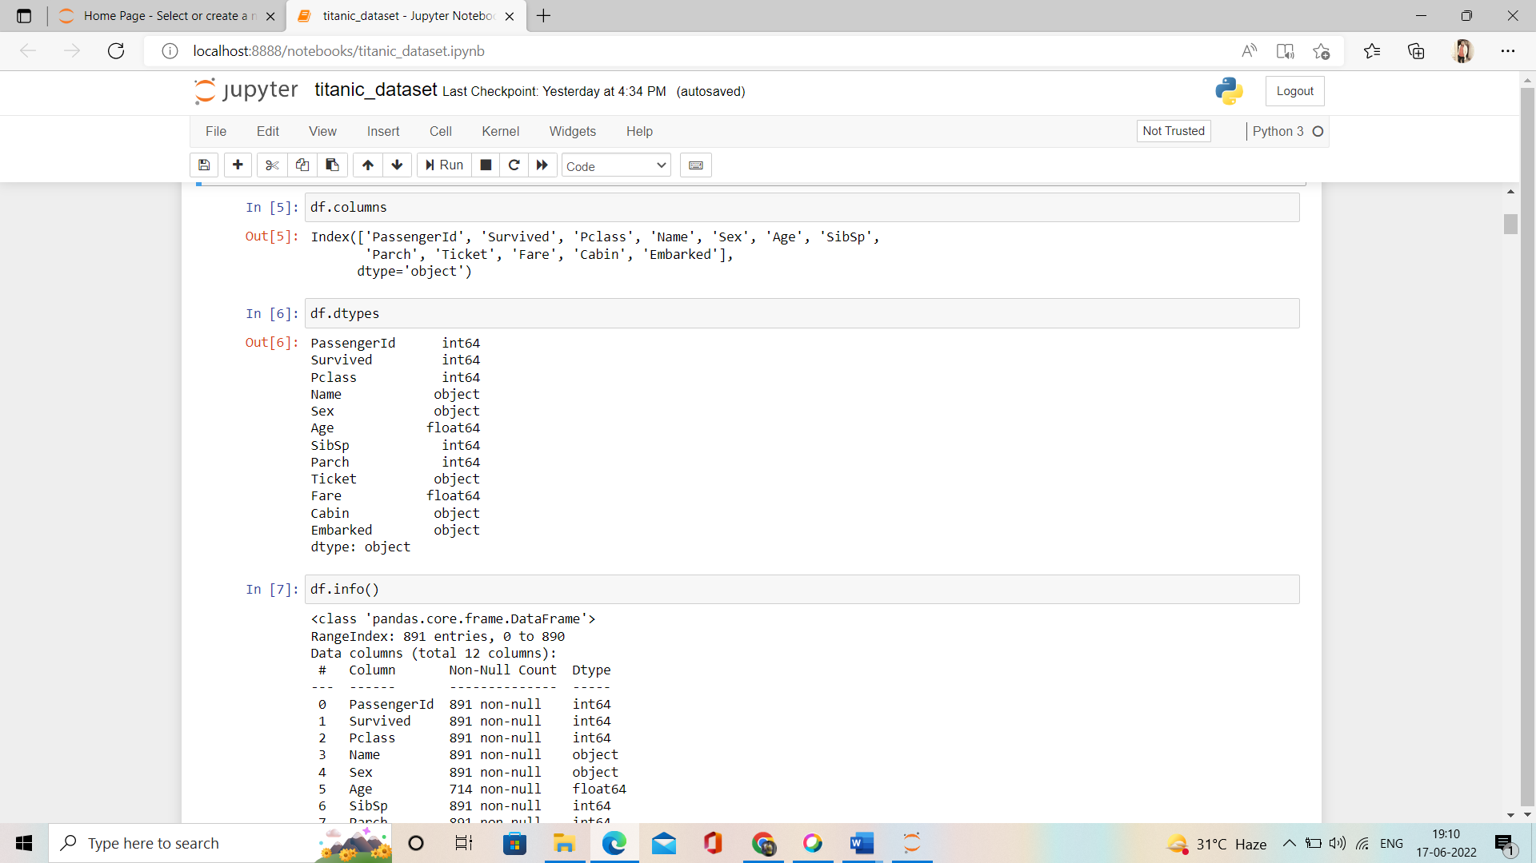

**dtypes**



* **Here we can see that we have int, float, and object datatype**

**Info()**

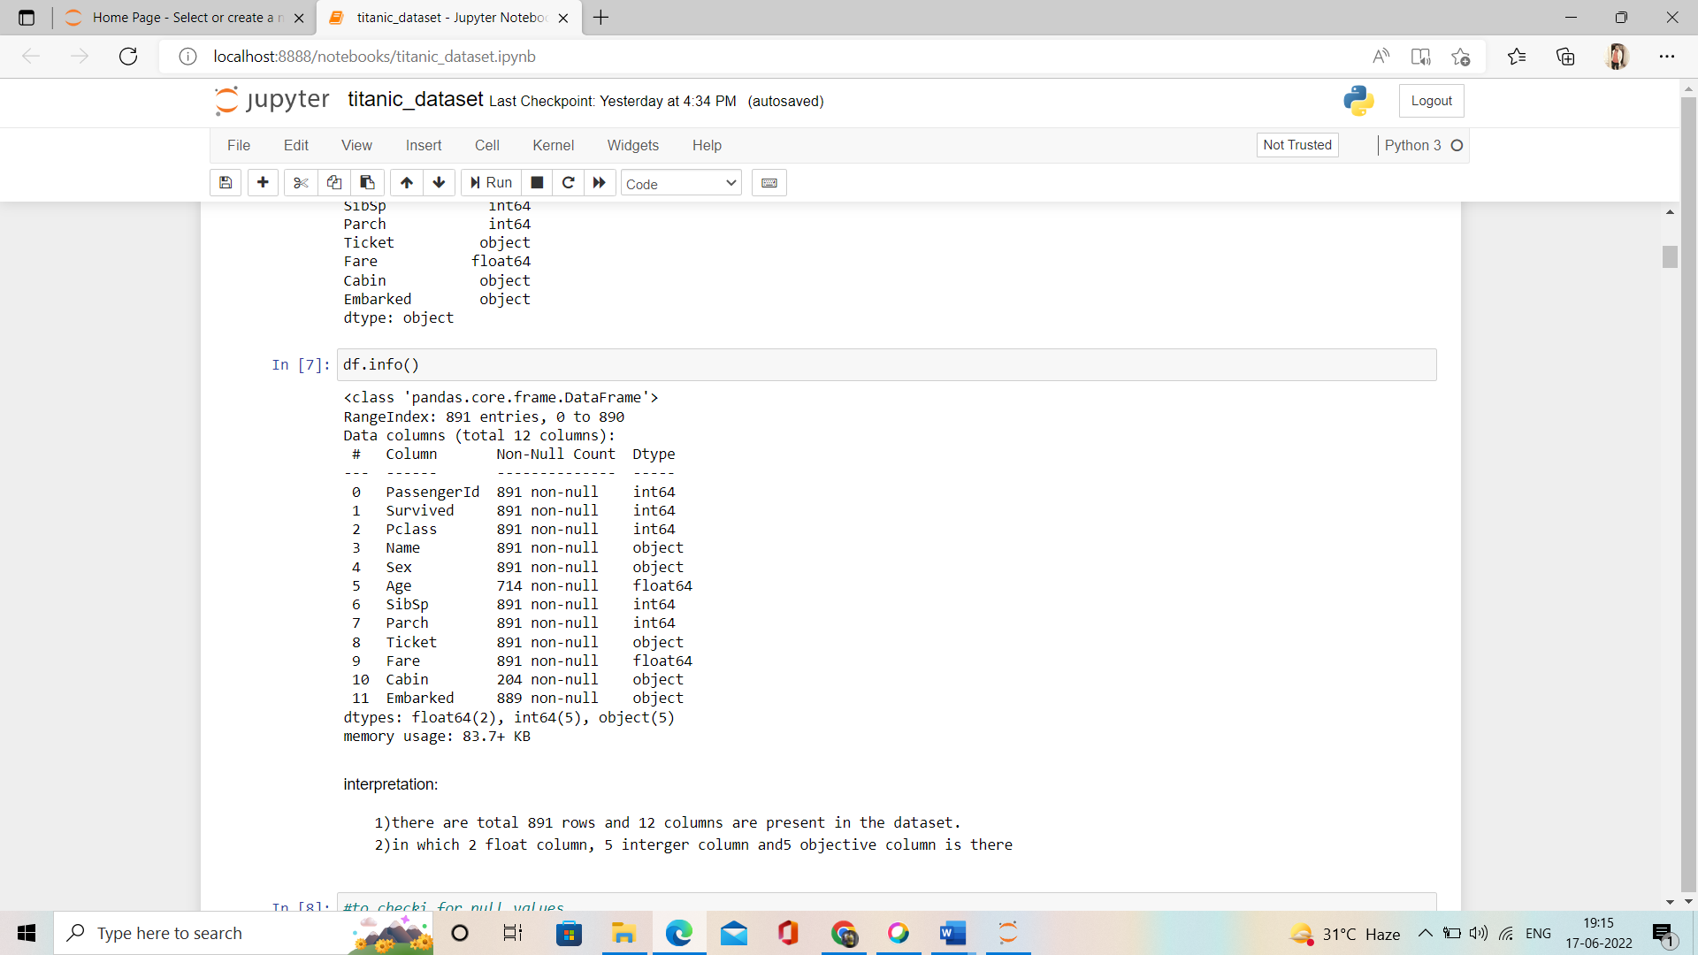

interpretation:

   1)there are total 891 rows and 12 columns are present in the dataset.

   2)in which 2 float column, 5 integer column and5 objective column is there

**EDA(Exploratory Data Analysis)**

Without any hesitation we can say that EDA, that is Exploratory Data Analysis is heart for building of machine learning model . This is the utmost important part that every dataset must be go through it . EDA is process use various of procedure or method to make our dataset into appropriate format so we can achieve our real target. In this EDA we do entire dataset analysis via using various using tools and python libraries.

**Isnull**

* By using isnull we can check null values present in the dataset. 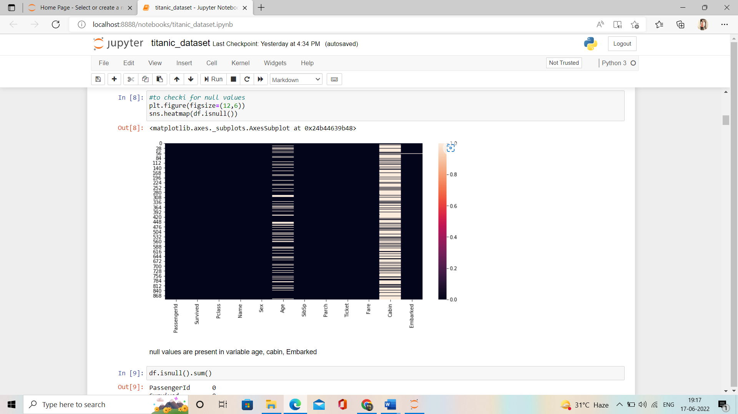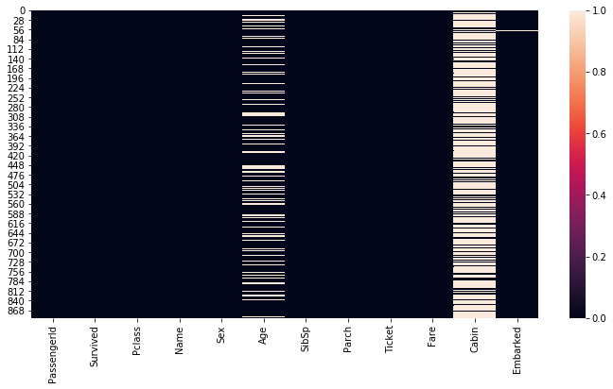
* we can see that we have null values at Age, cabin and Embarked columns.
* let’s check with the count of null values in each of columns so that we can work on it accordingly.

**isnull().sum()**

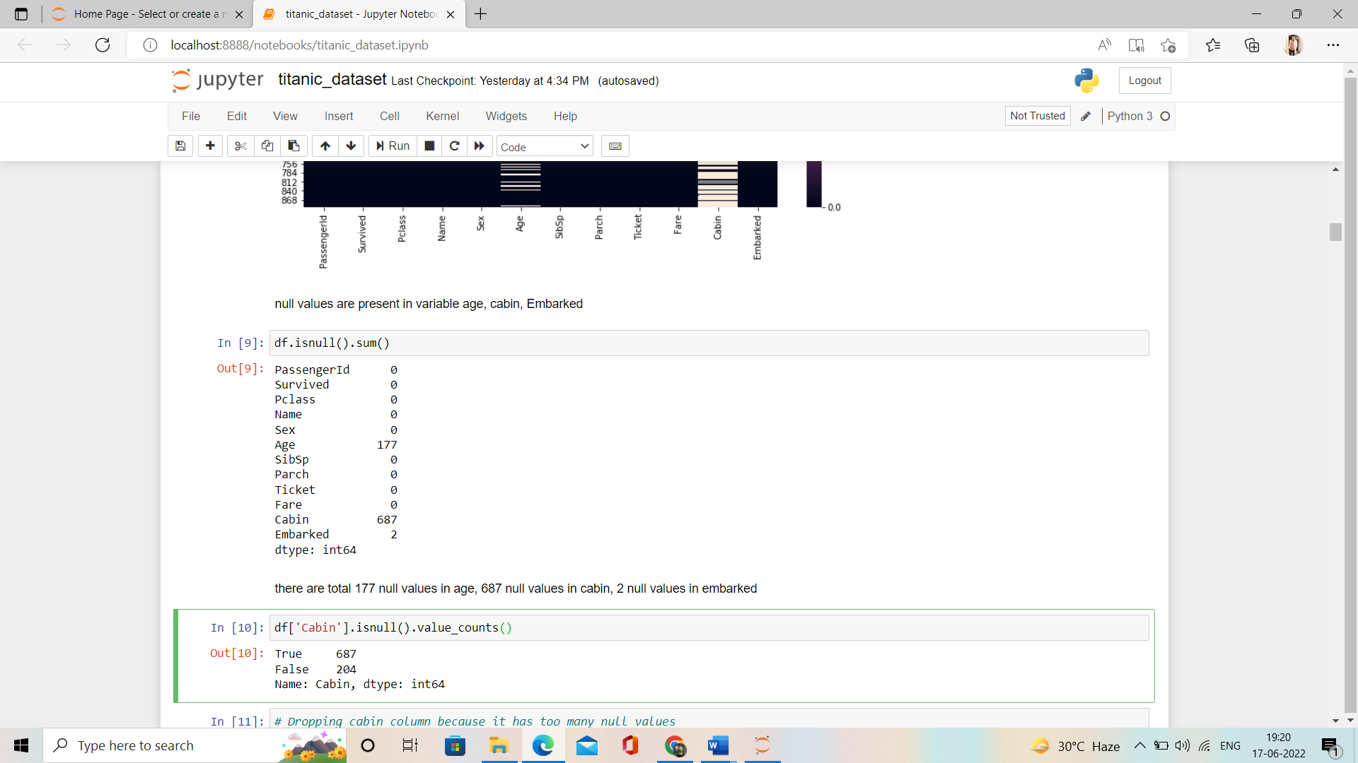

* there is total 177 null values in age, 687 null values in cabin, 2 null values in embarked

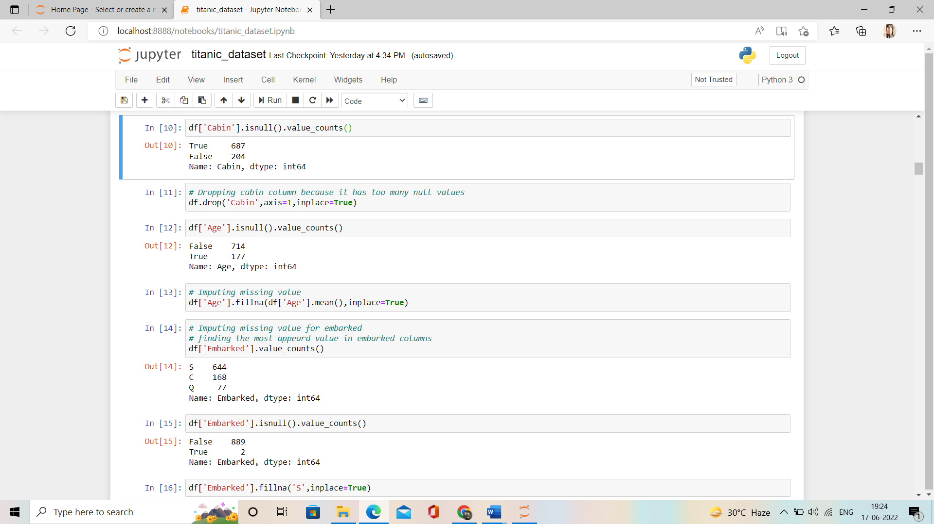

* We can see thatmore than 50% of the cabin values are null

So to deal wth that we have tp drop the column.



* We can see that there are comparatively low null values in age column so we can take the average age (Mean).







* We have only 2 null value in Embarked column so we will fill them with fillna



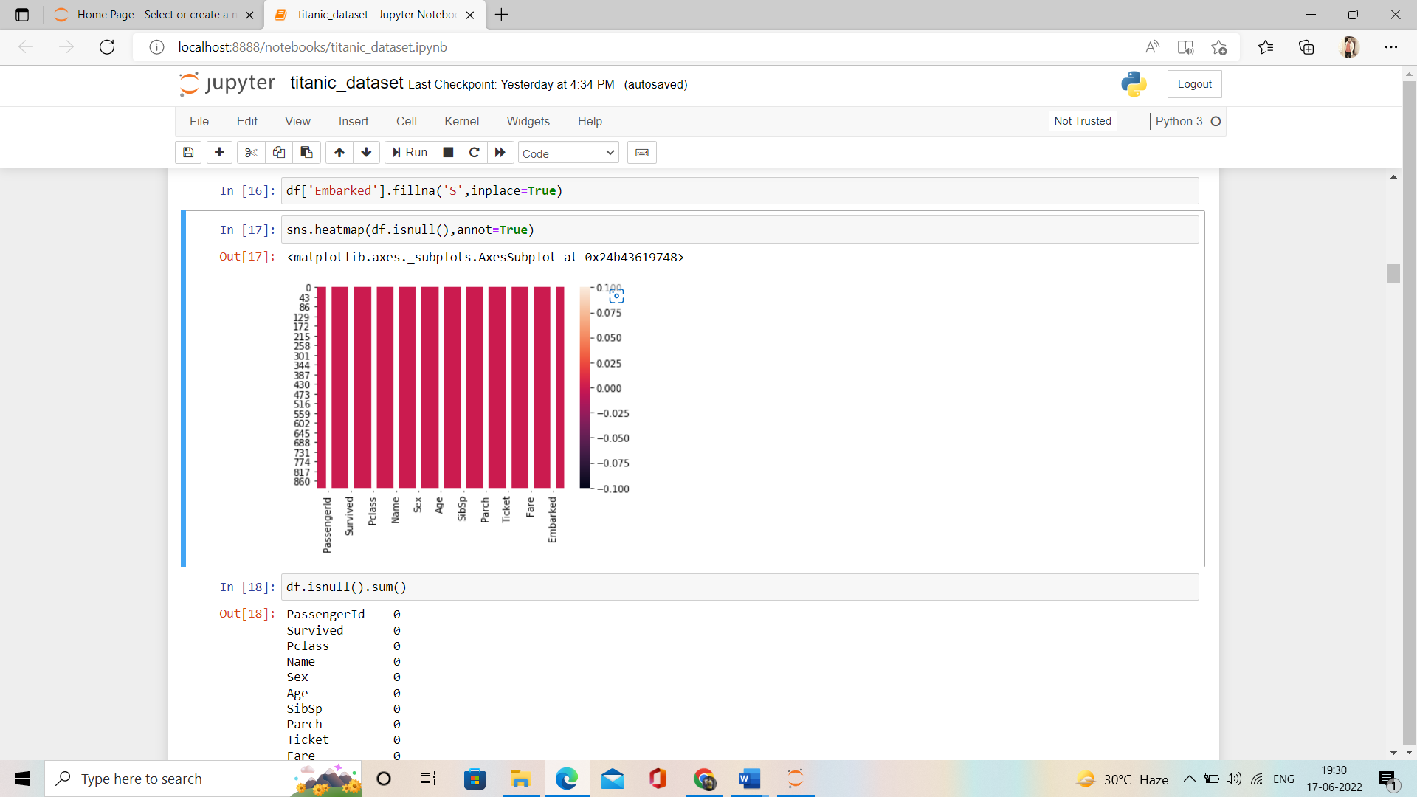

* We can see now we don’t have any null value in our dataset.



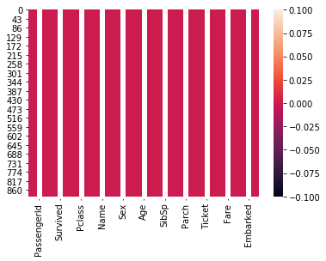

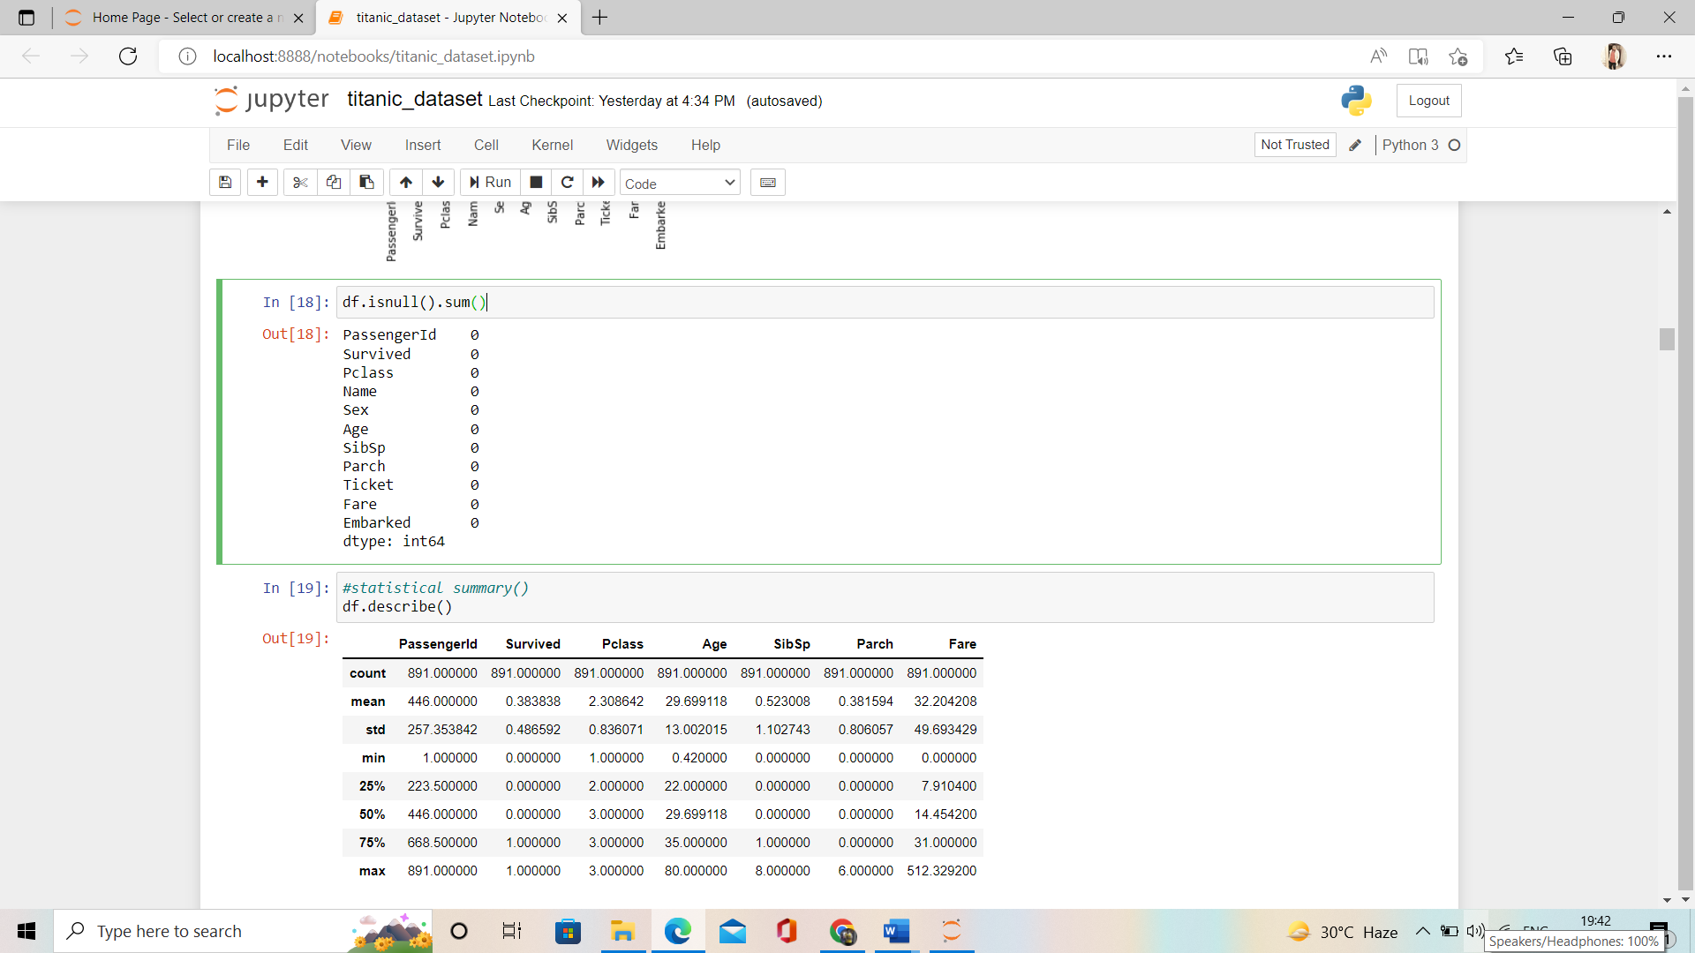

**describe()**

The describe() function **computes a summary of statistics pertaining to the DataFrame columns**.



interpretation:

* Variation present in the passengerld.
* Most of variable having median zero.
* Difference in third quartile and max value are high so outliers may present.
* We will check the correlation of the dataset we have

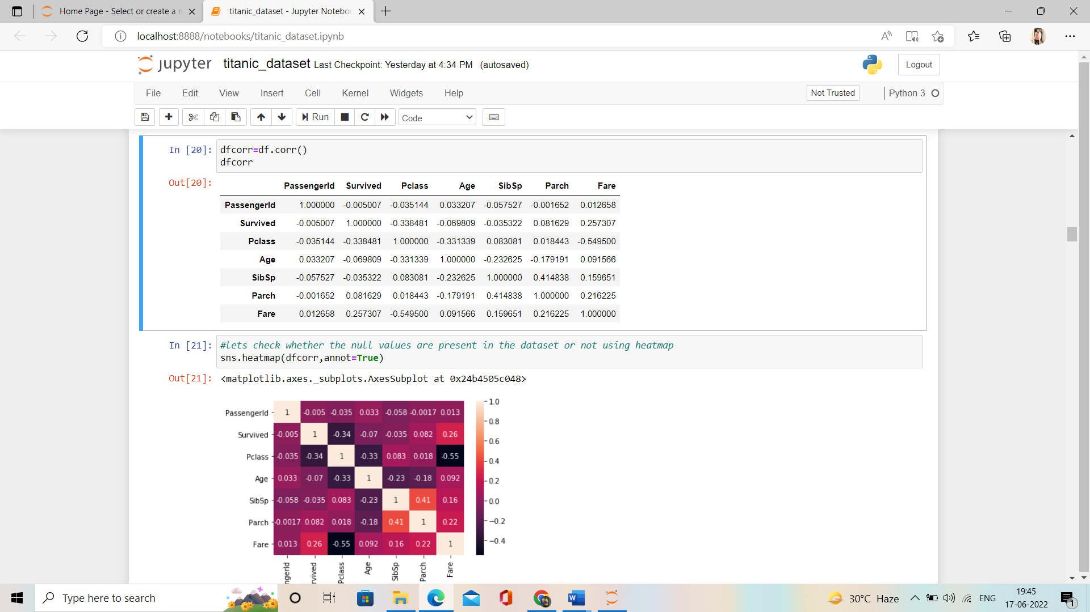

* Checking the correlation using heat map.

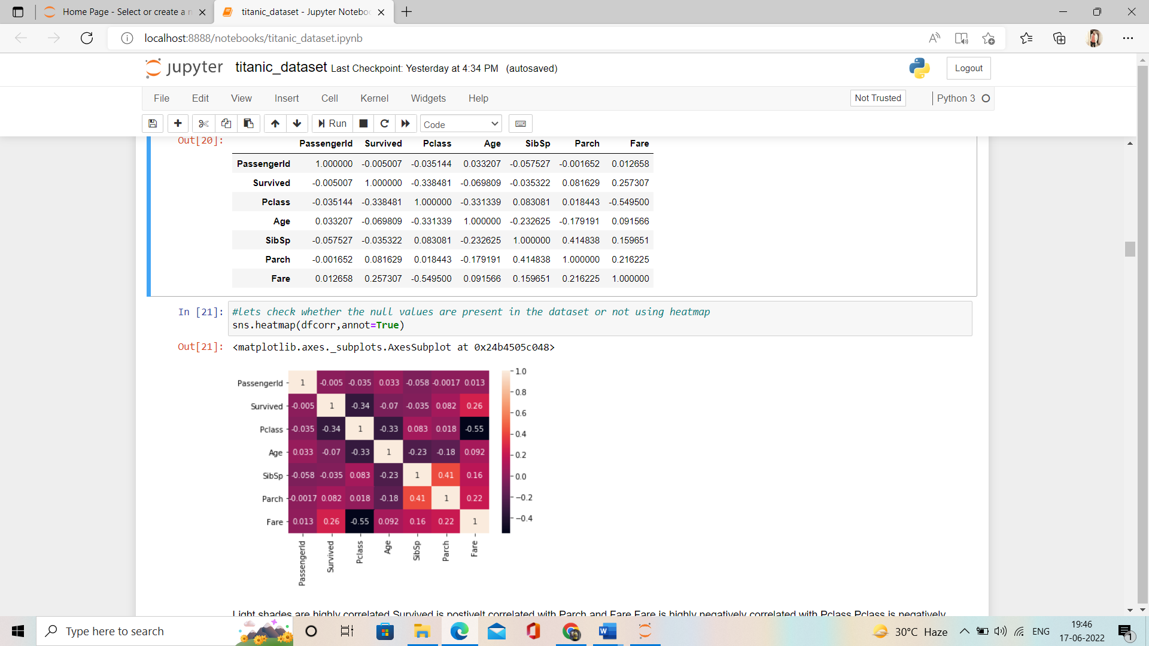

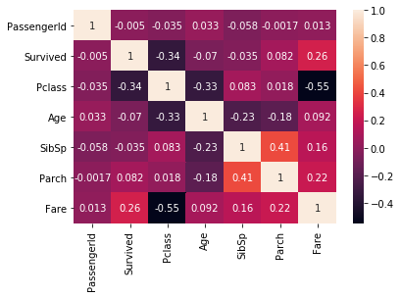

interpretation:

* Light shades are highly correlated Survived is positively correlated with Parch and Fare is highly negatively correlated with Pclass.
* Pclass is negatively correlated with Survived.

**Univariate Analysis:**

 univariate analysis refers to **the analysis of one variable**

**Seaborn** is a library for making statistical graphics.

We have countplot, histogram, violinplots etc..

countplot()

method is **used to Show the counts of observations in each categorical bin using bars**.

Violinplots()

are **similar to box plots, except that they also show the probability density of the data at different values**

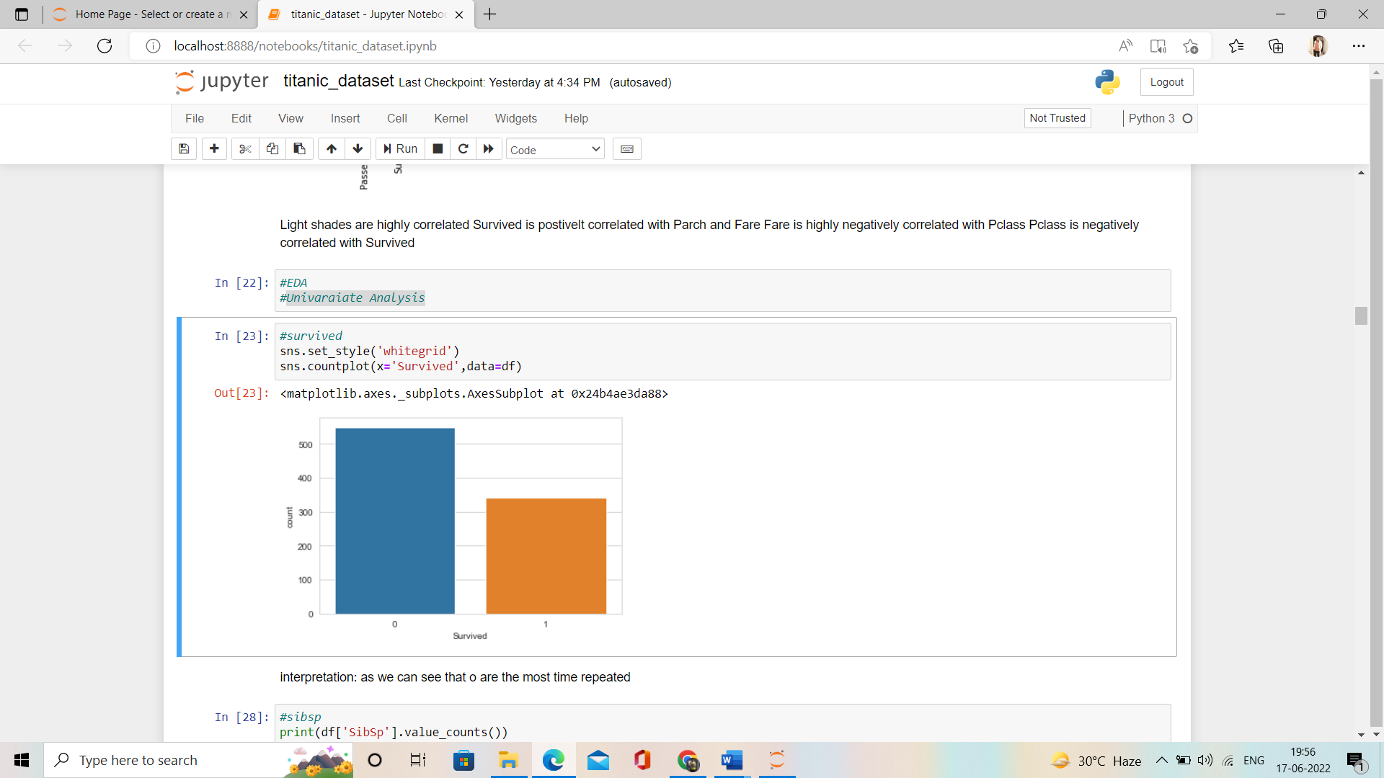

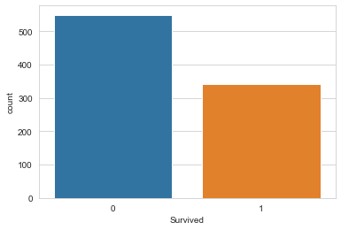

interpretation:

* as we can see that **o** are the most time repeated

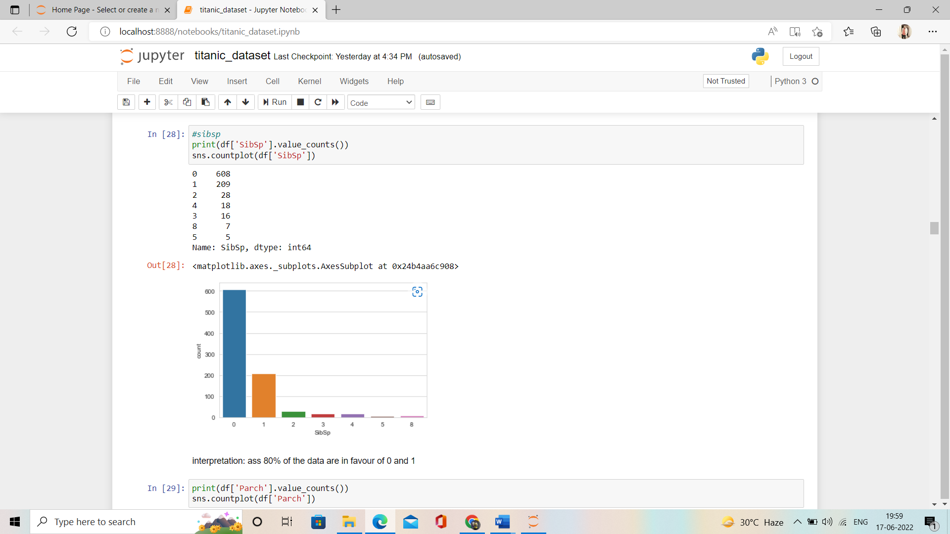

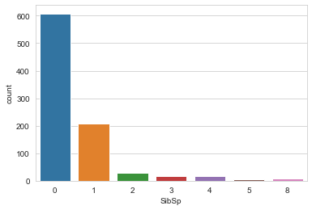

interpretation: ass 80% of the data are in favour of 0 and 1

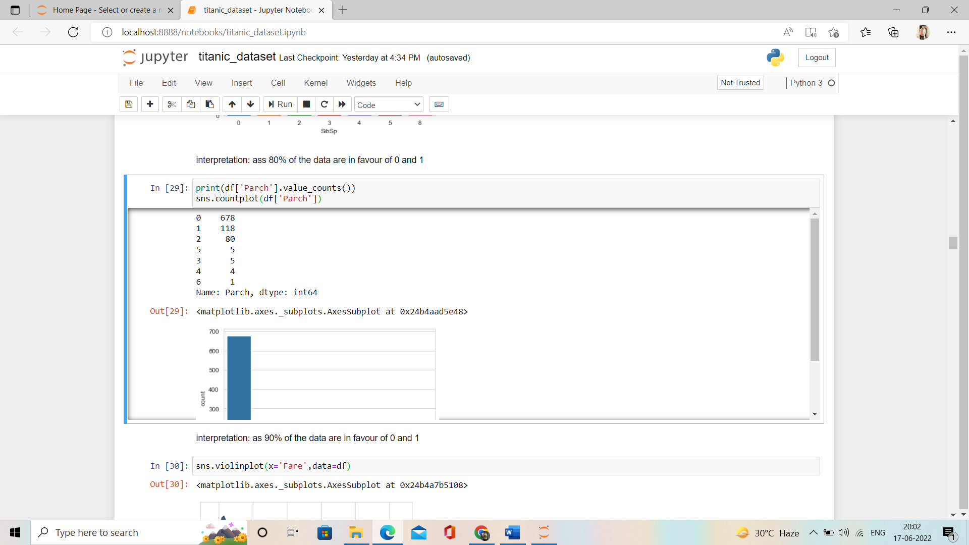

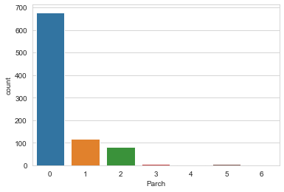

interpretation:

* as 90% of the data are in favour of 0 and 1

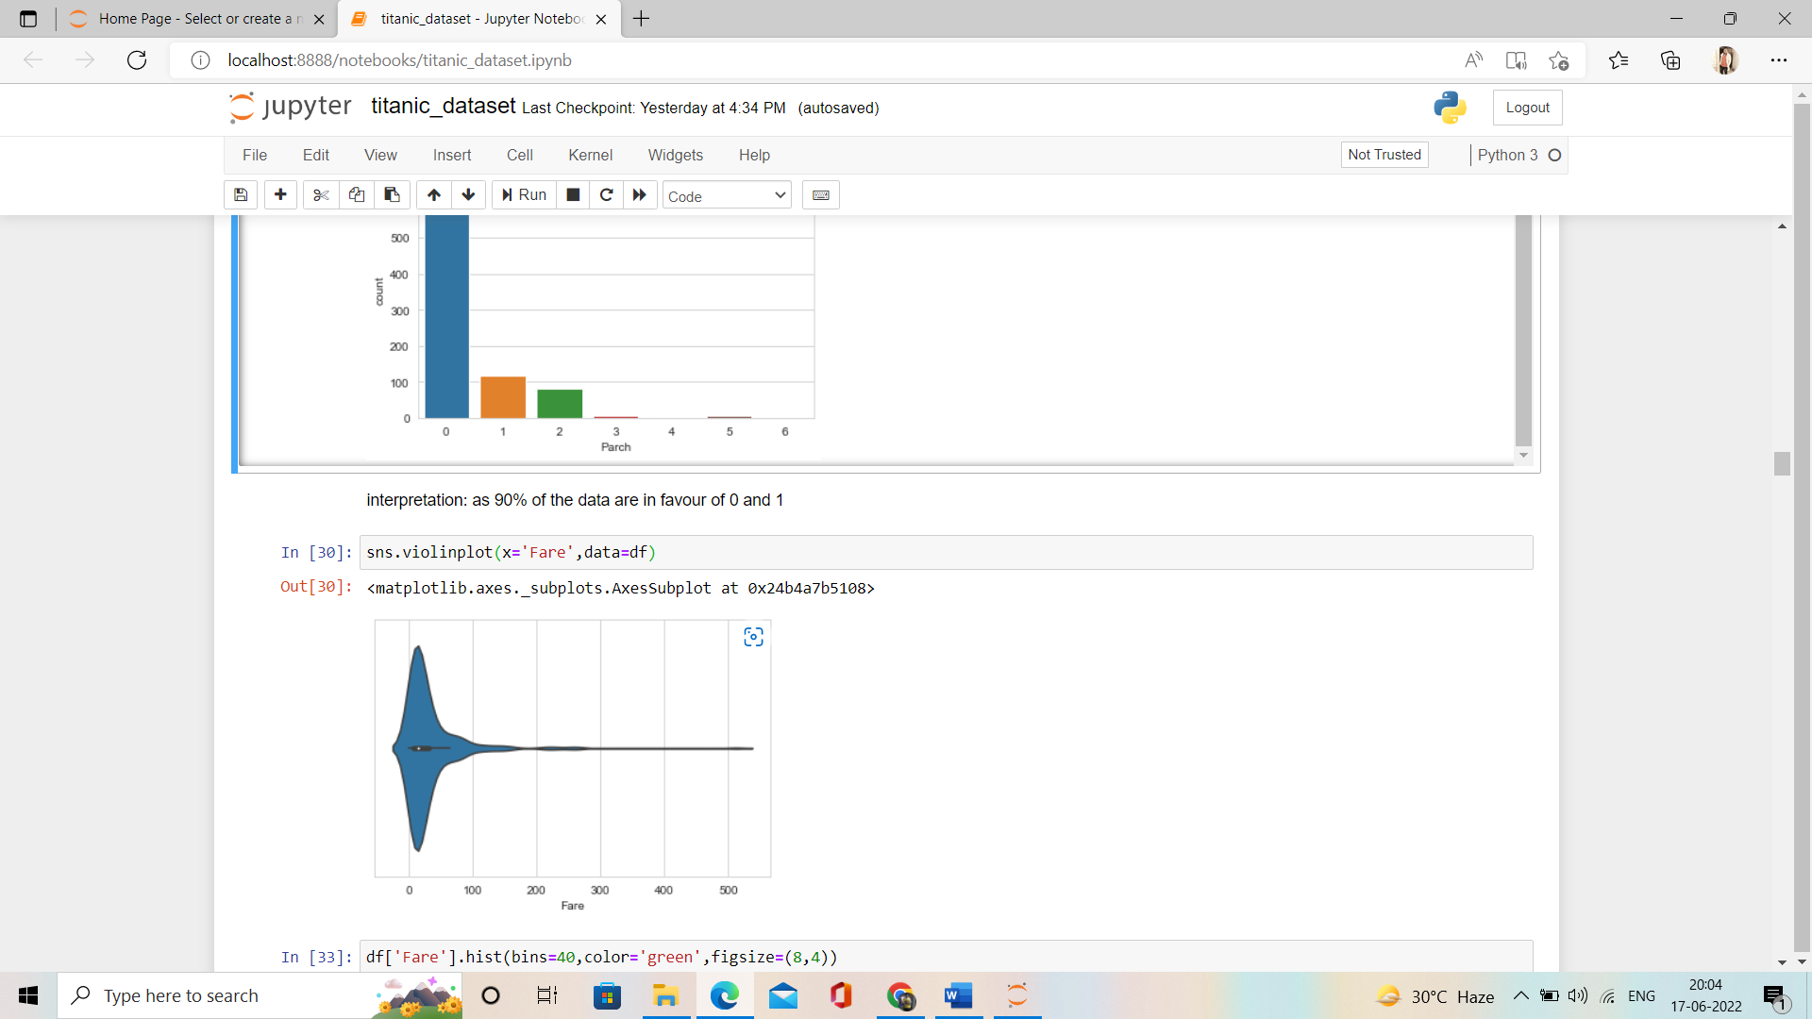

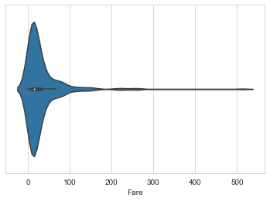

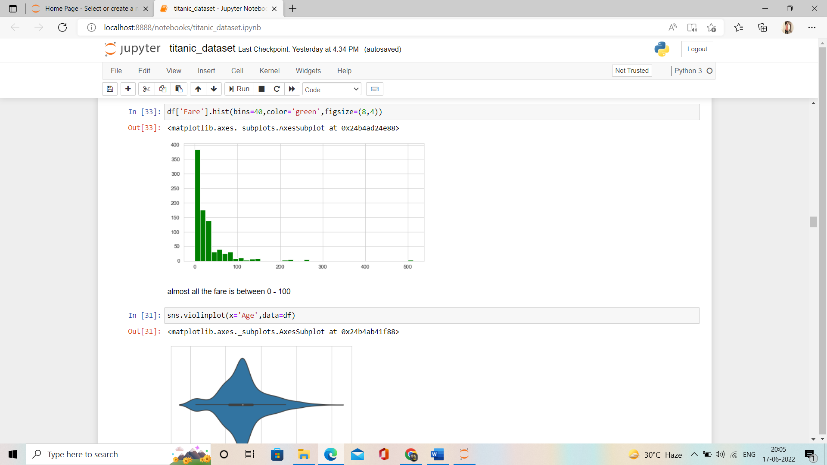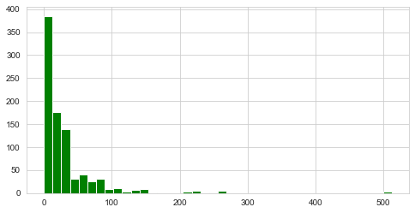



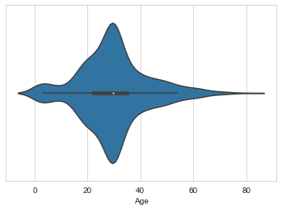

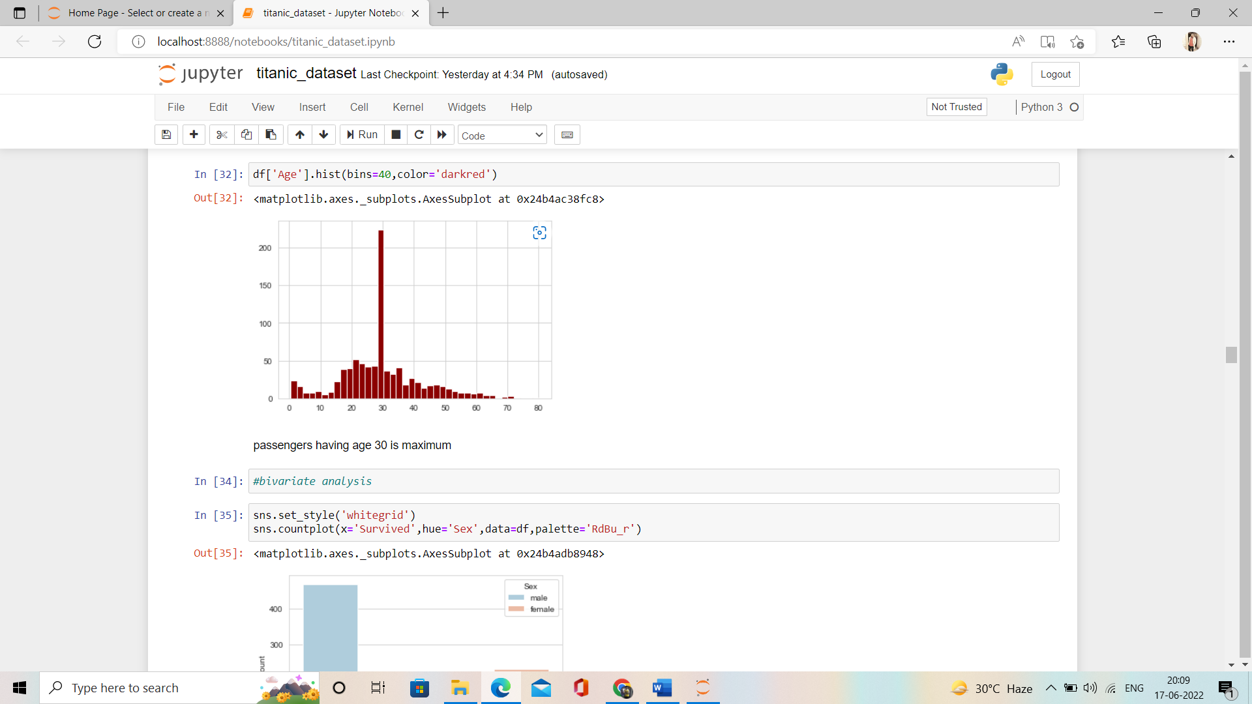

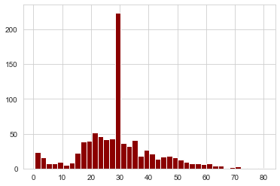

* passengers having age 30 is maximum

**bivariate analysis:**

 bivariate analysis refers to **the analysis of two variables**.

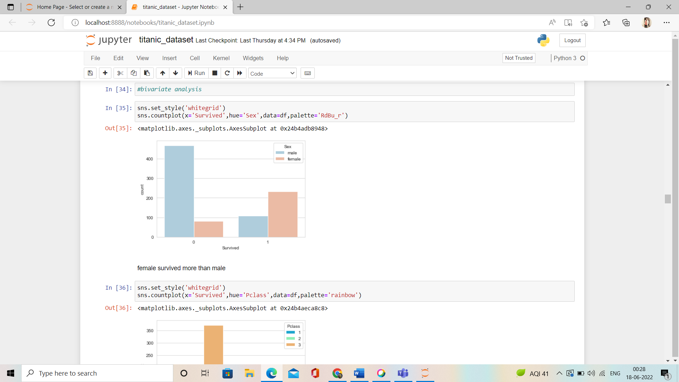

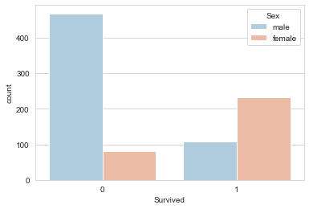

**female survived more than male**

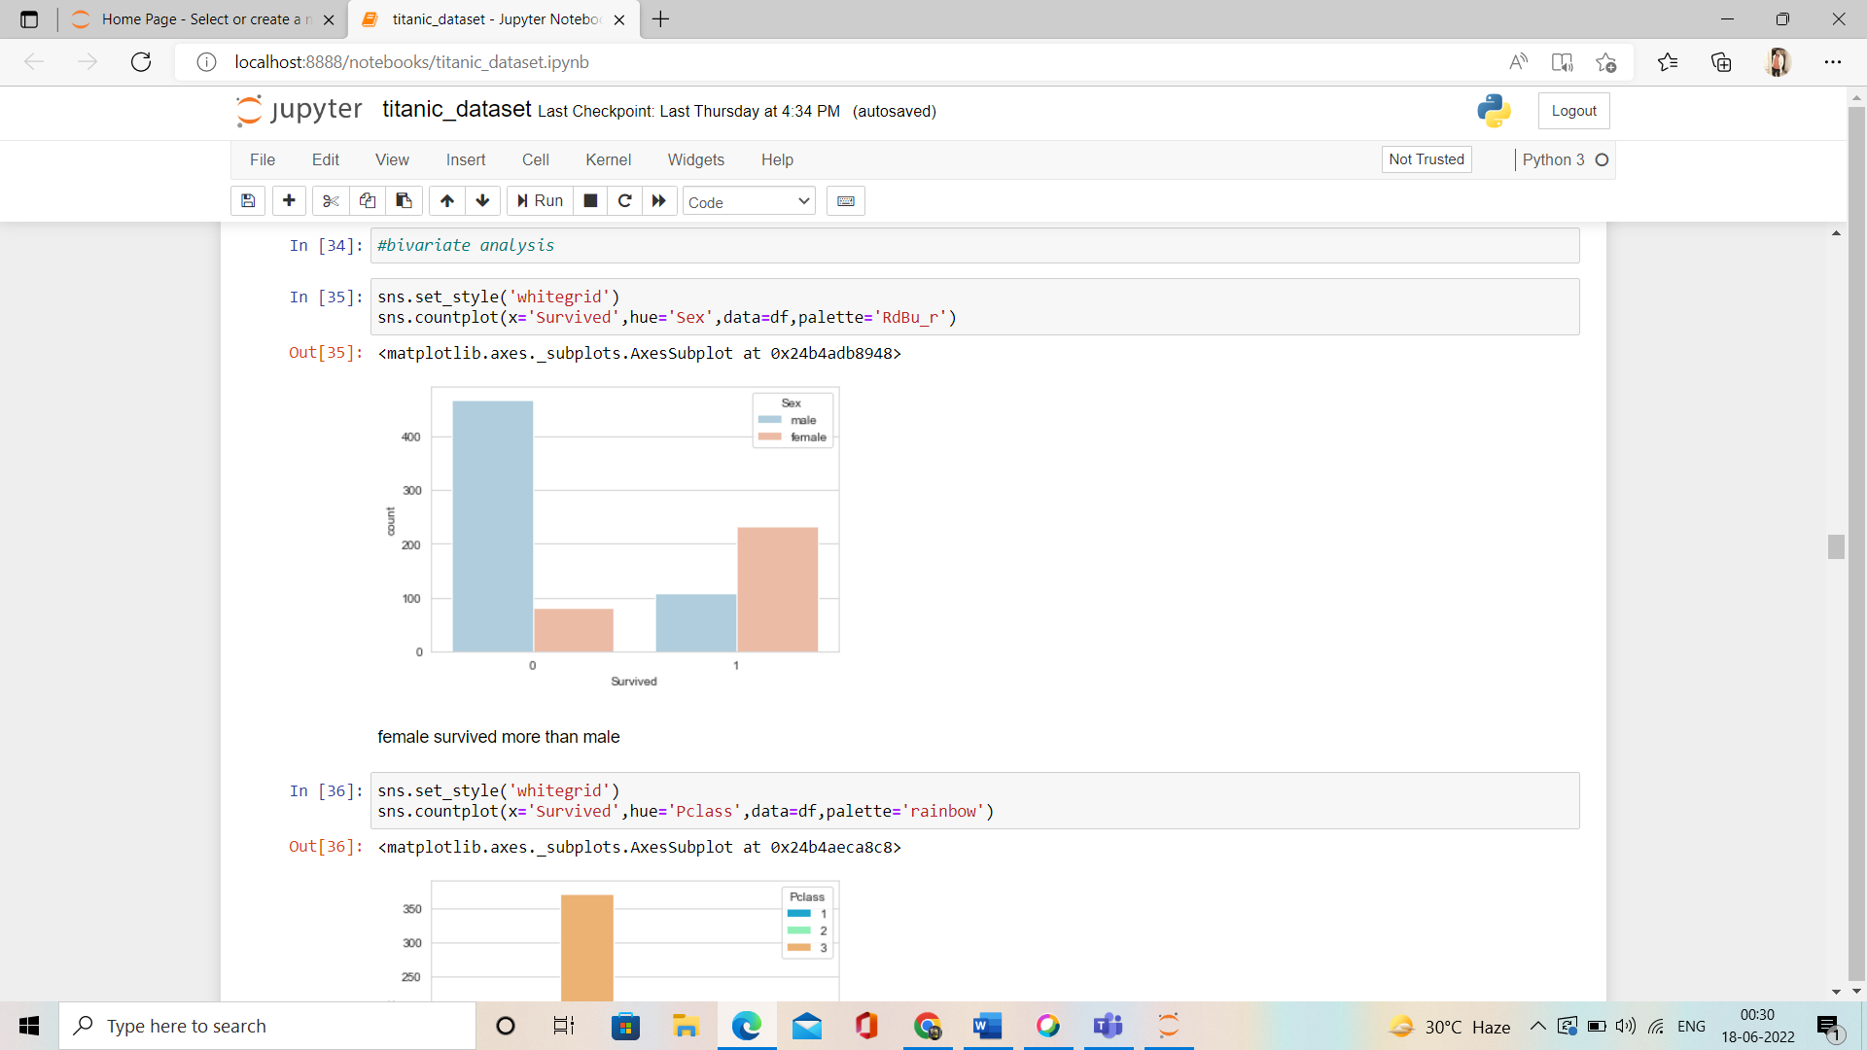

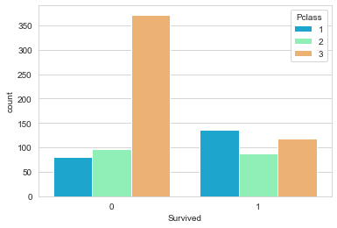

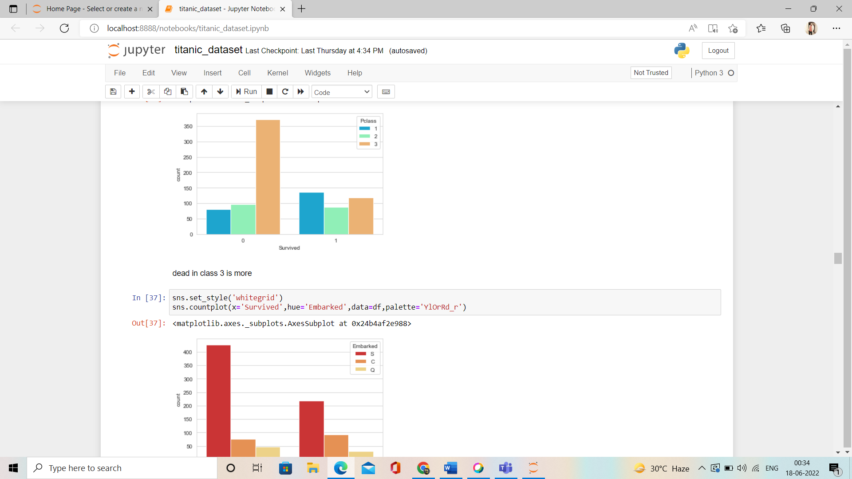

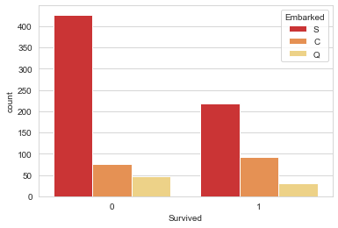

* dead in class 3 is more

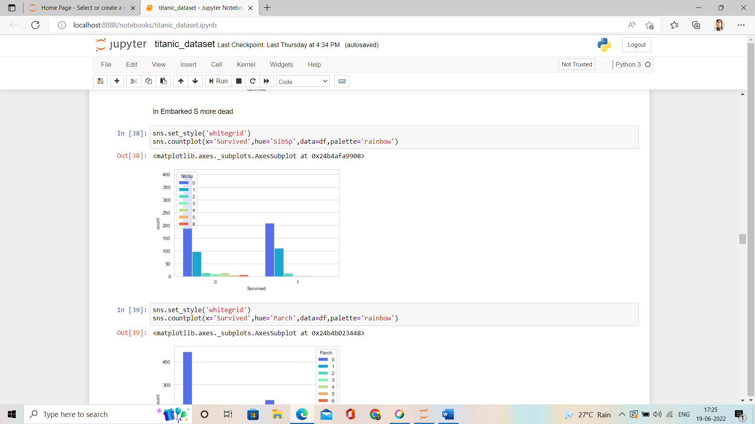

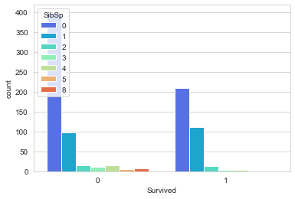

* In Embarked S more dead

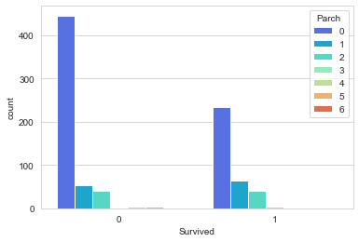

* parch having zero are more dead**.**

**multivariate data analysis**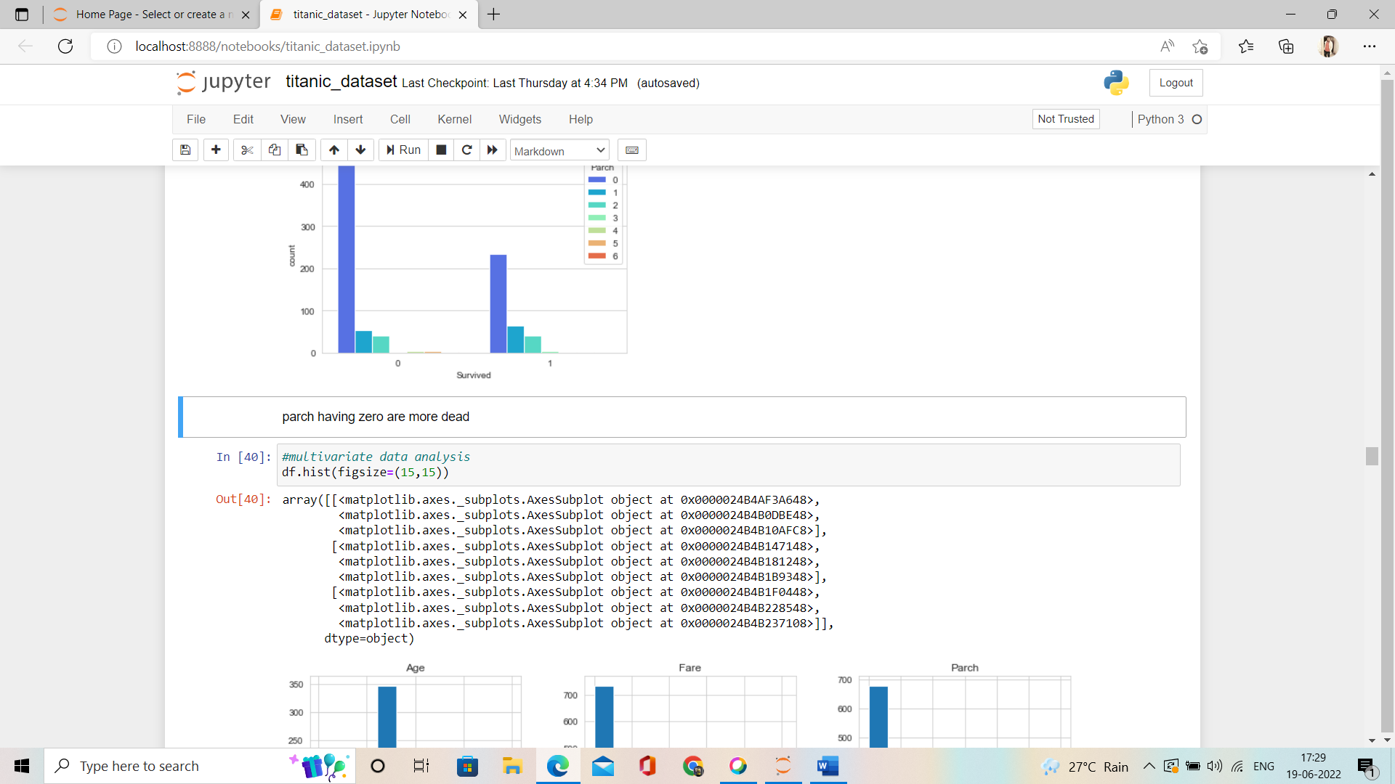 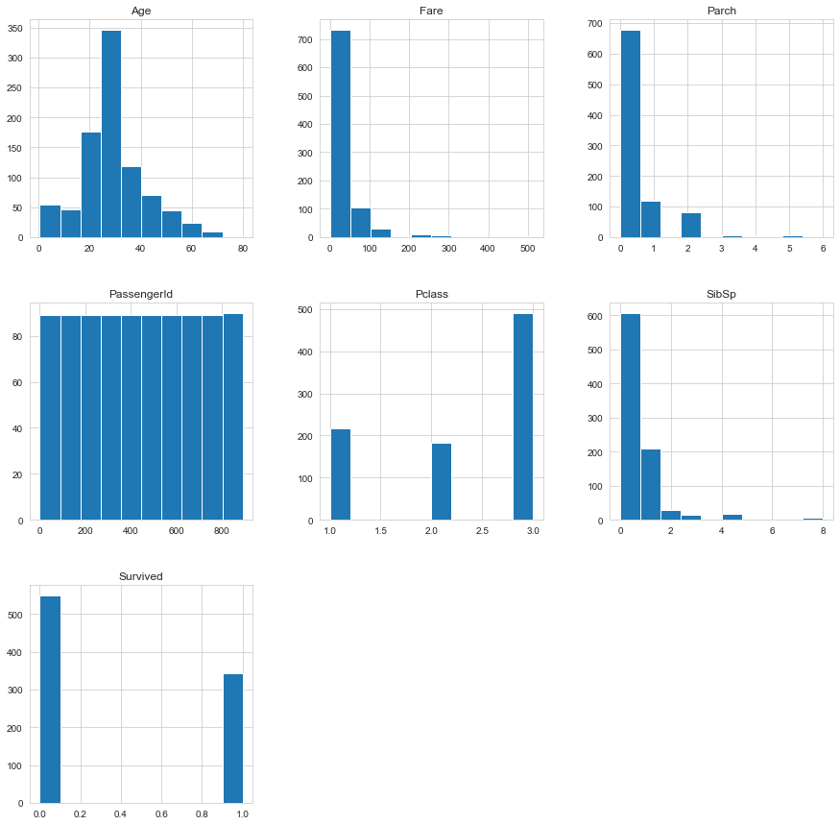

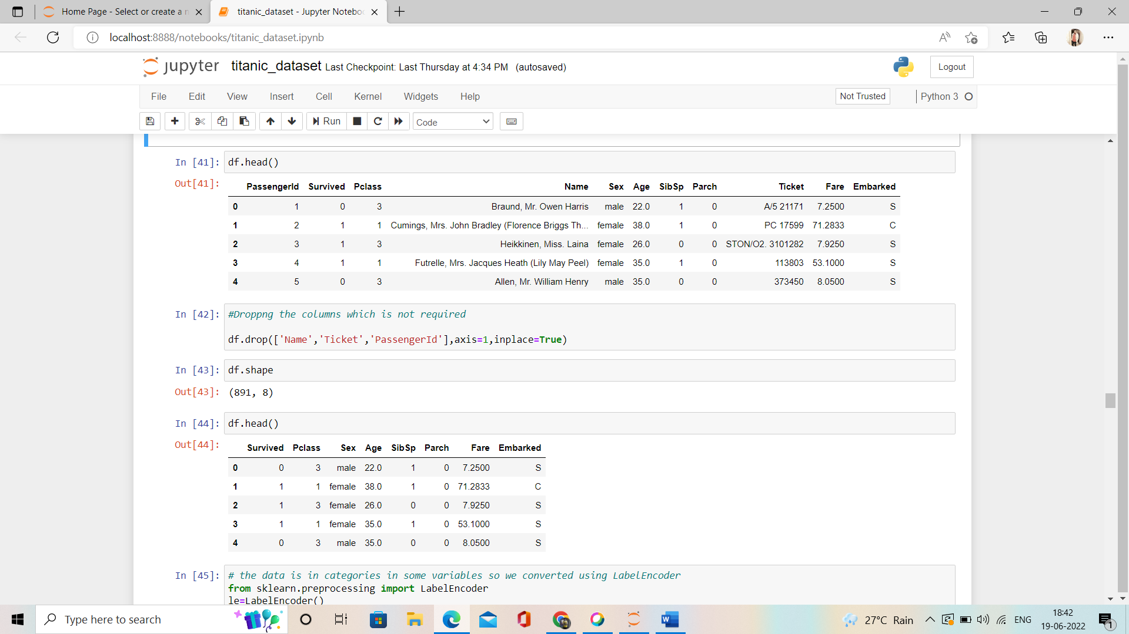We will drop some of the columns which are not required like passengerId, Name, and Ticket.



Now er have the columns in our data set are:



We have columns with categorical data so we have to convert those into numerical form for that we have to use **LabelEncoder.**

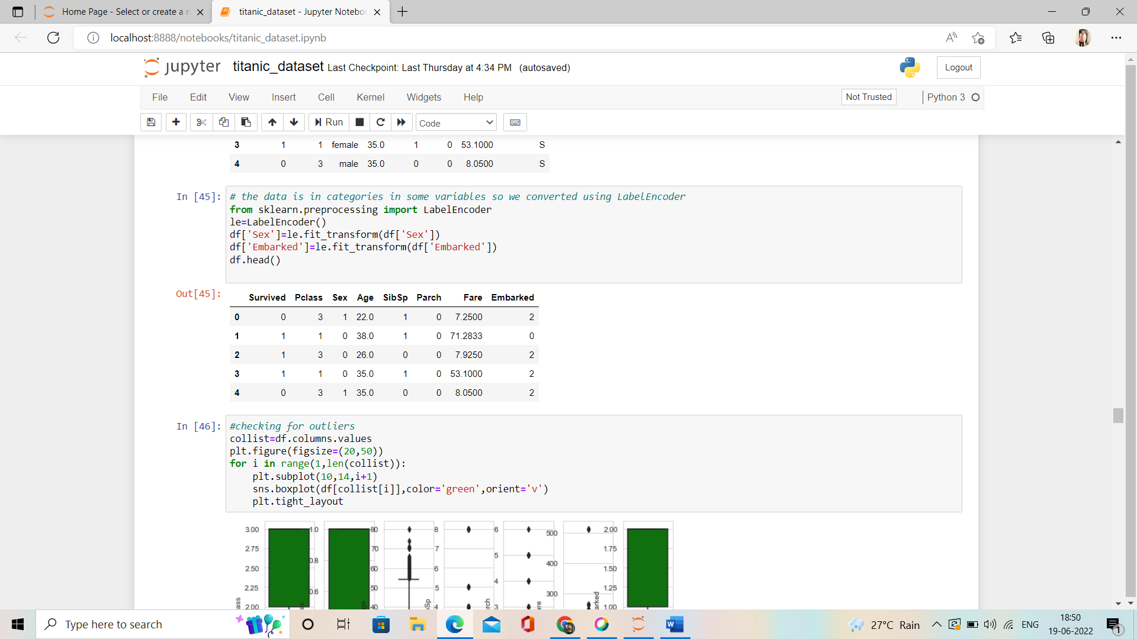

We can see that all the column values are in numerical form.



**Outlier**

outliers are **values within a dataset that vary greatly from the others**—they're either much larger, or significantly smaller.

Checking for outlier

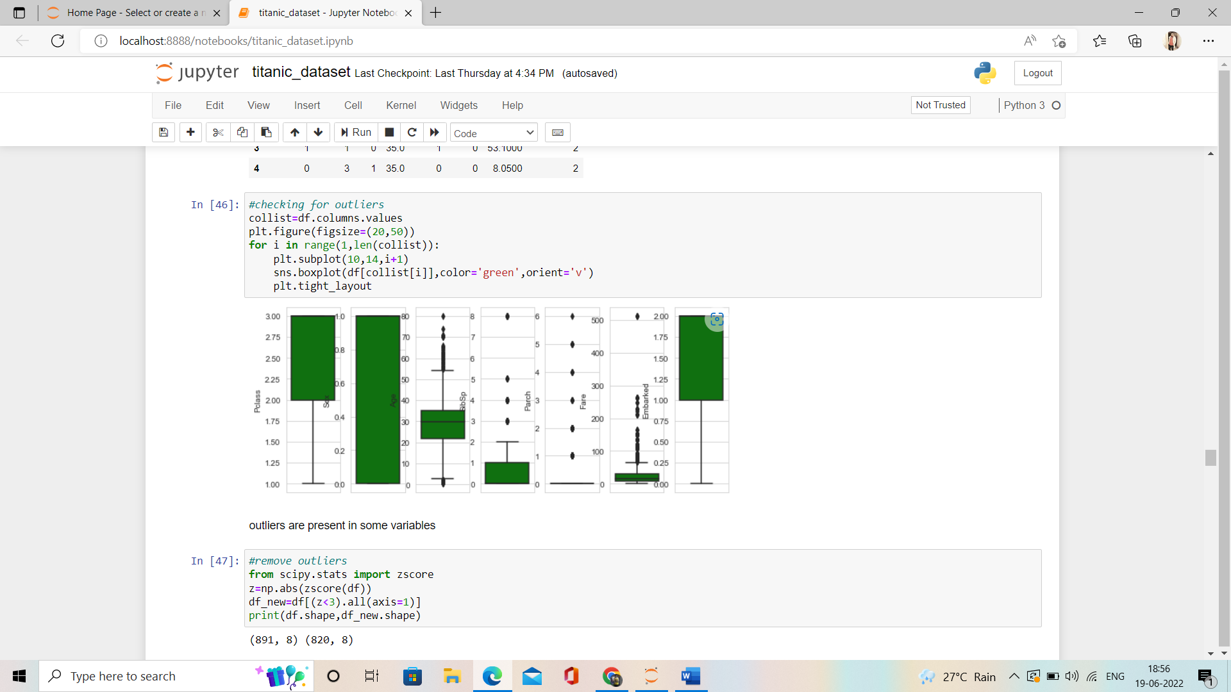

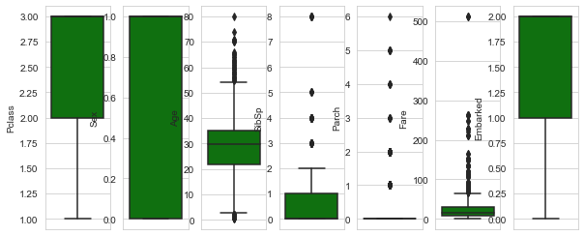

We can clearly see that outlier are present in the column values.

**Removing outlier**

We will remove the outlier using **Zscore.**

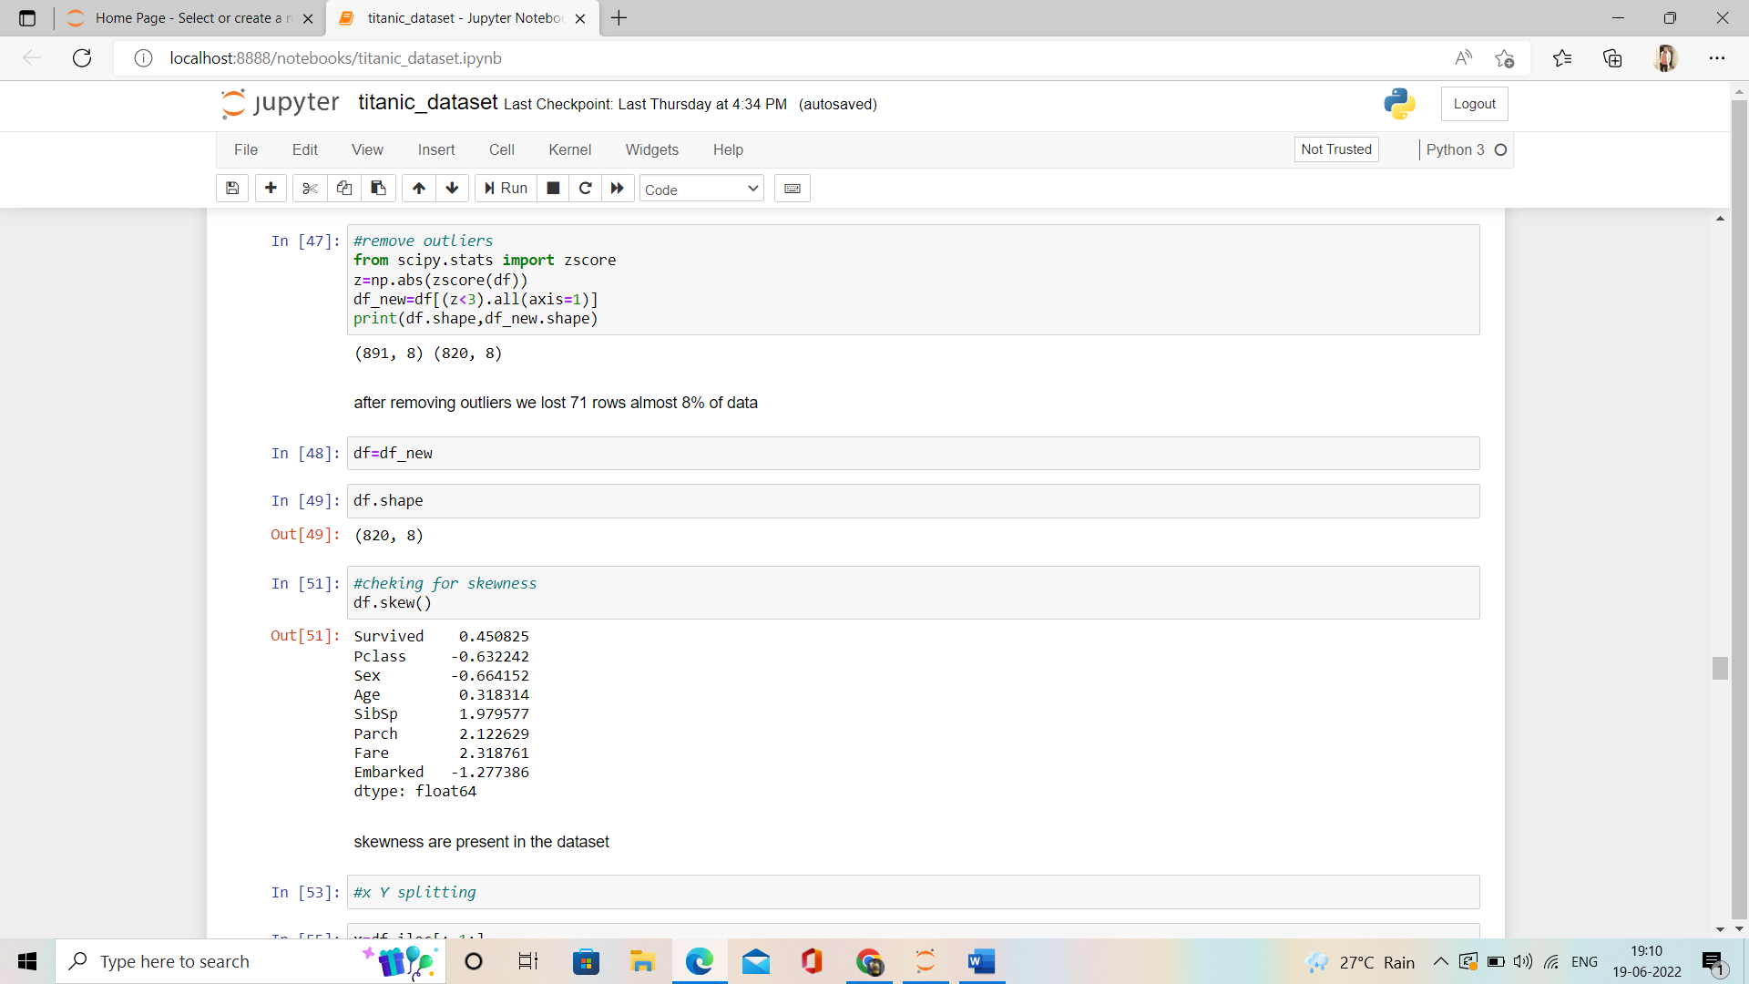

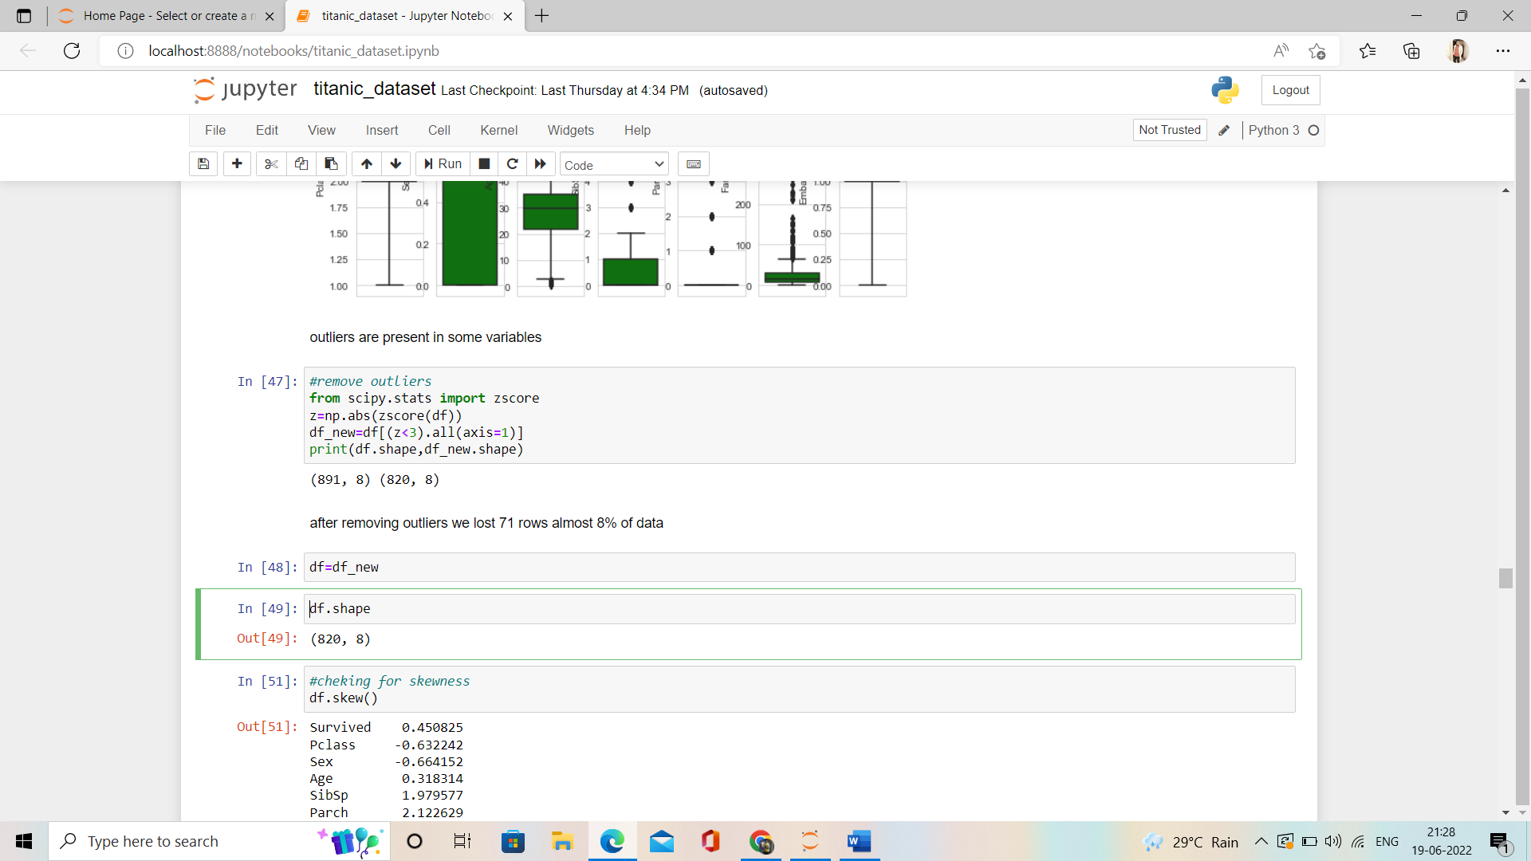

after removing outliers, we lost 71 rows almost 8% of data

**X-Y splitting**

Now our data is ready for test so we will divide the data into two-part dependent and independent variable as X and Y.

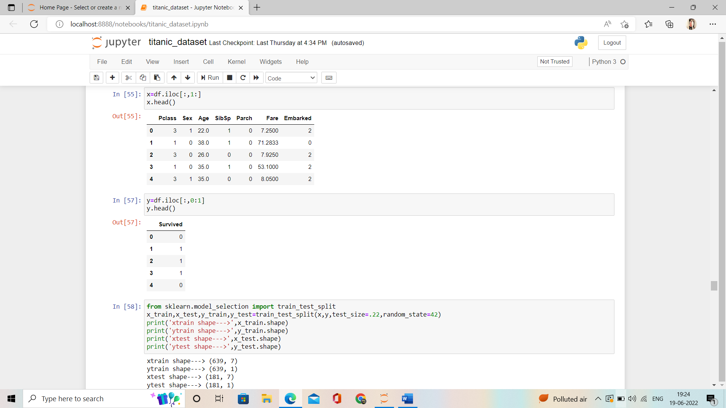



Now time for model building so let’s import some important libraries.

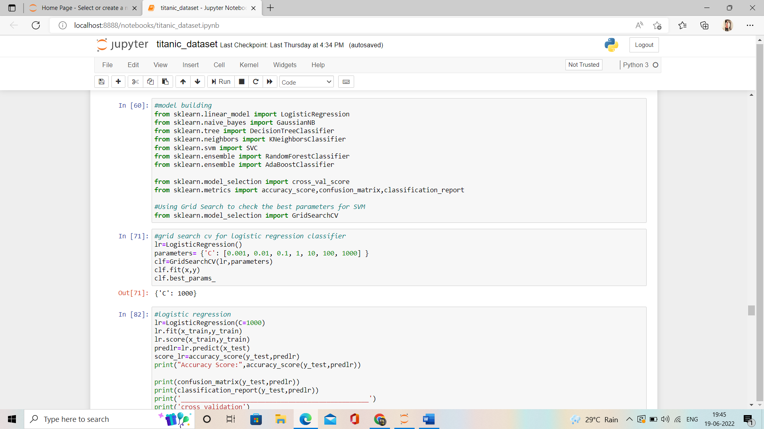

To test the data, we have to dived the data into test data and train data where certain amount of data will go for train and rest will go for train.



We have taken test_size=.22 which means 22% of the data we took for test and rest of the data goes for train.



**Model building :**

1. **Logistic Regression**

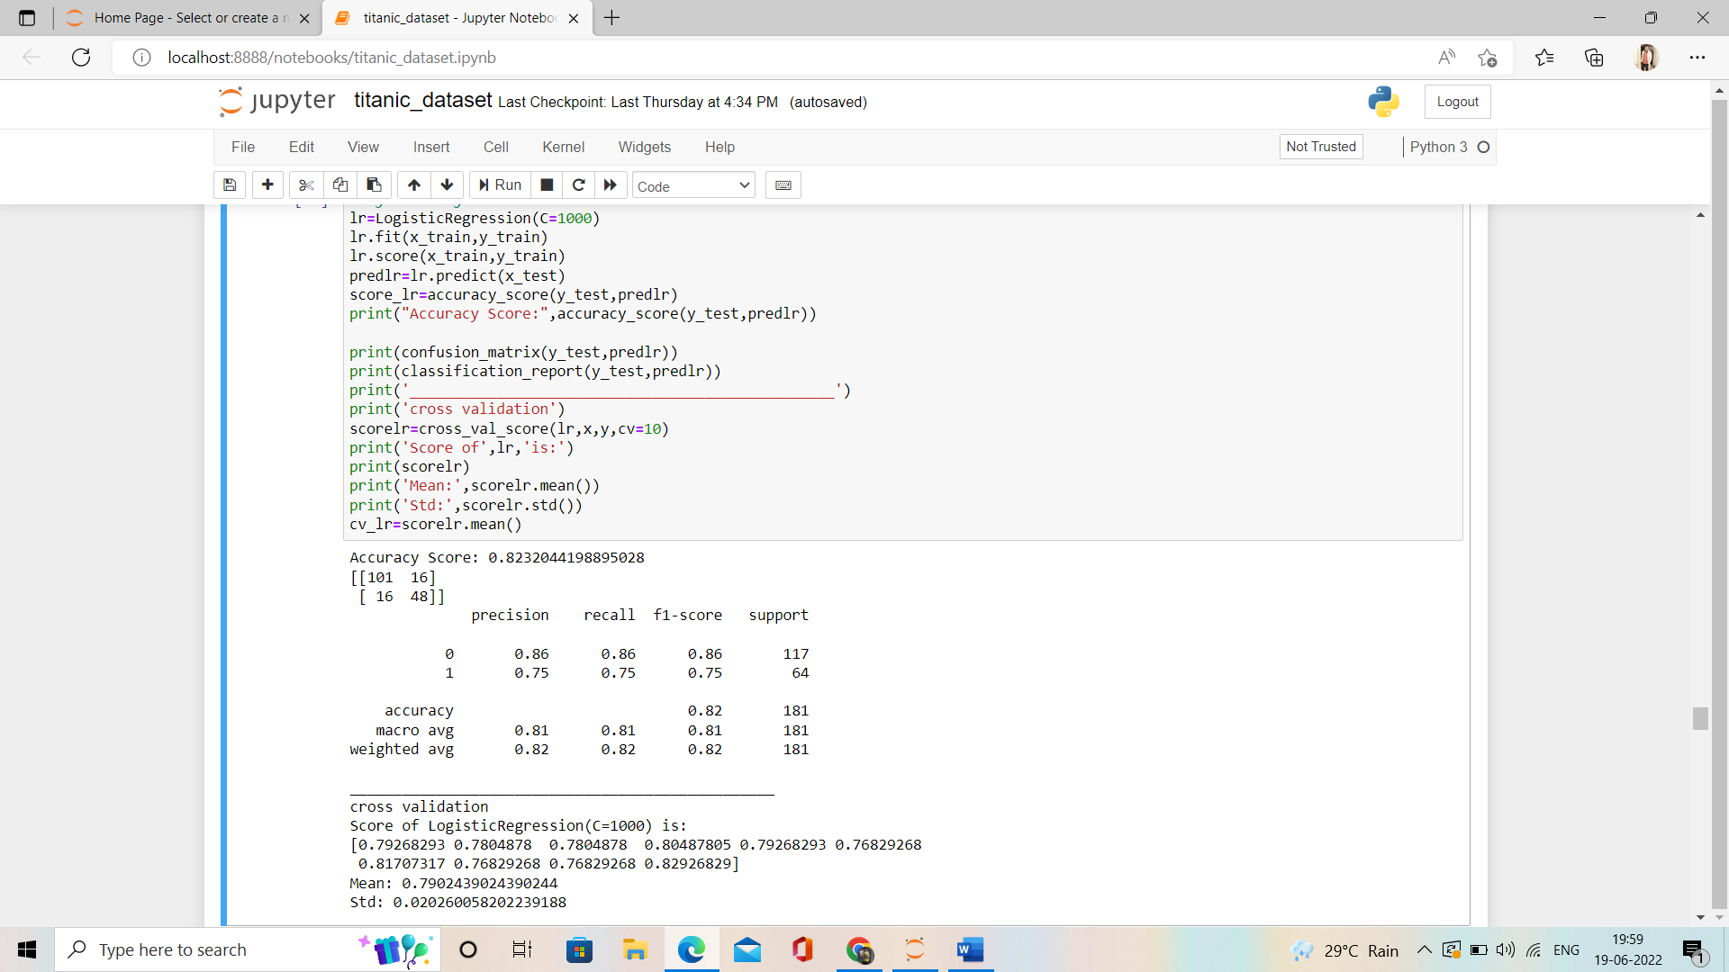

**2.Gaussion NB**

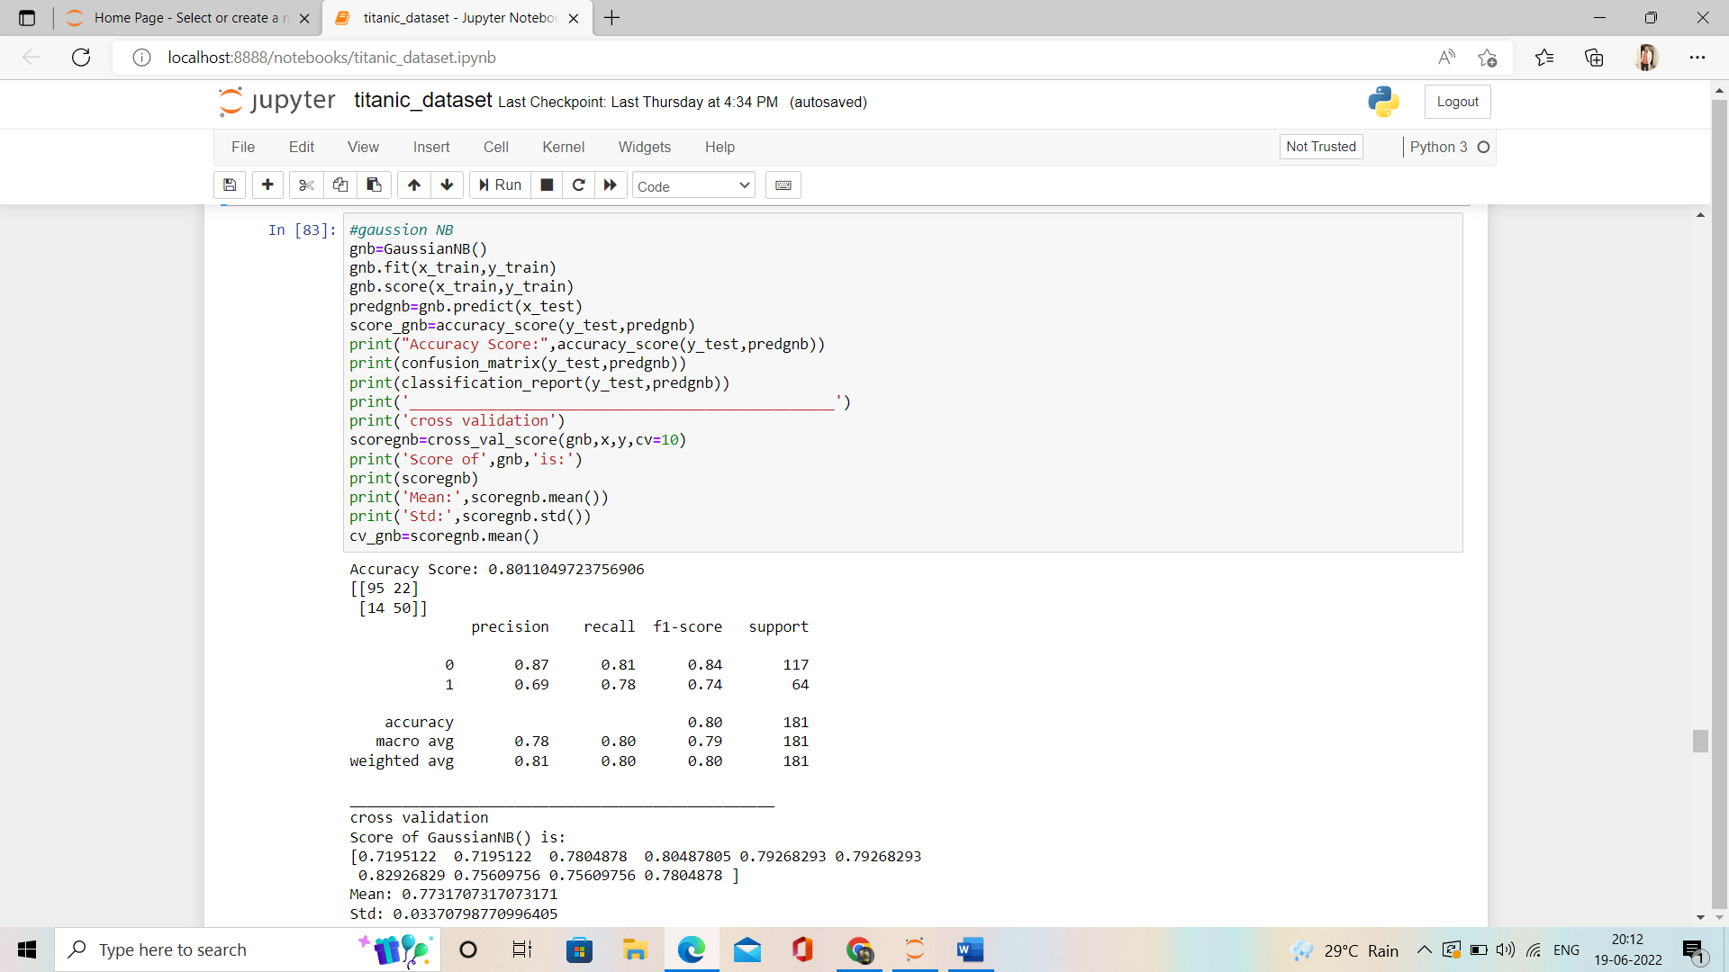

**3.RandomForestClassifier**

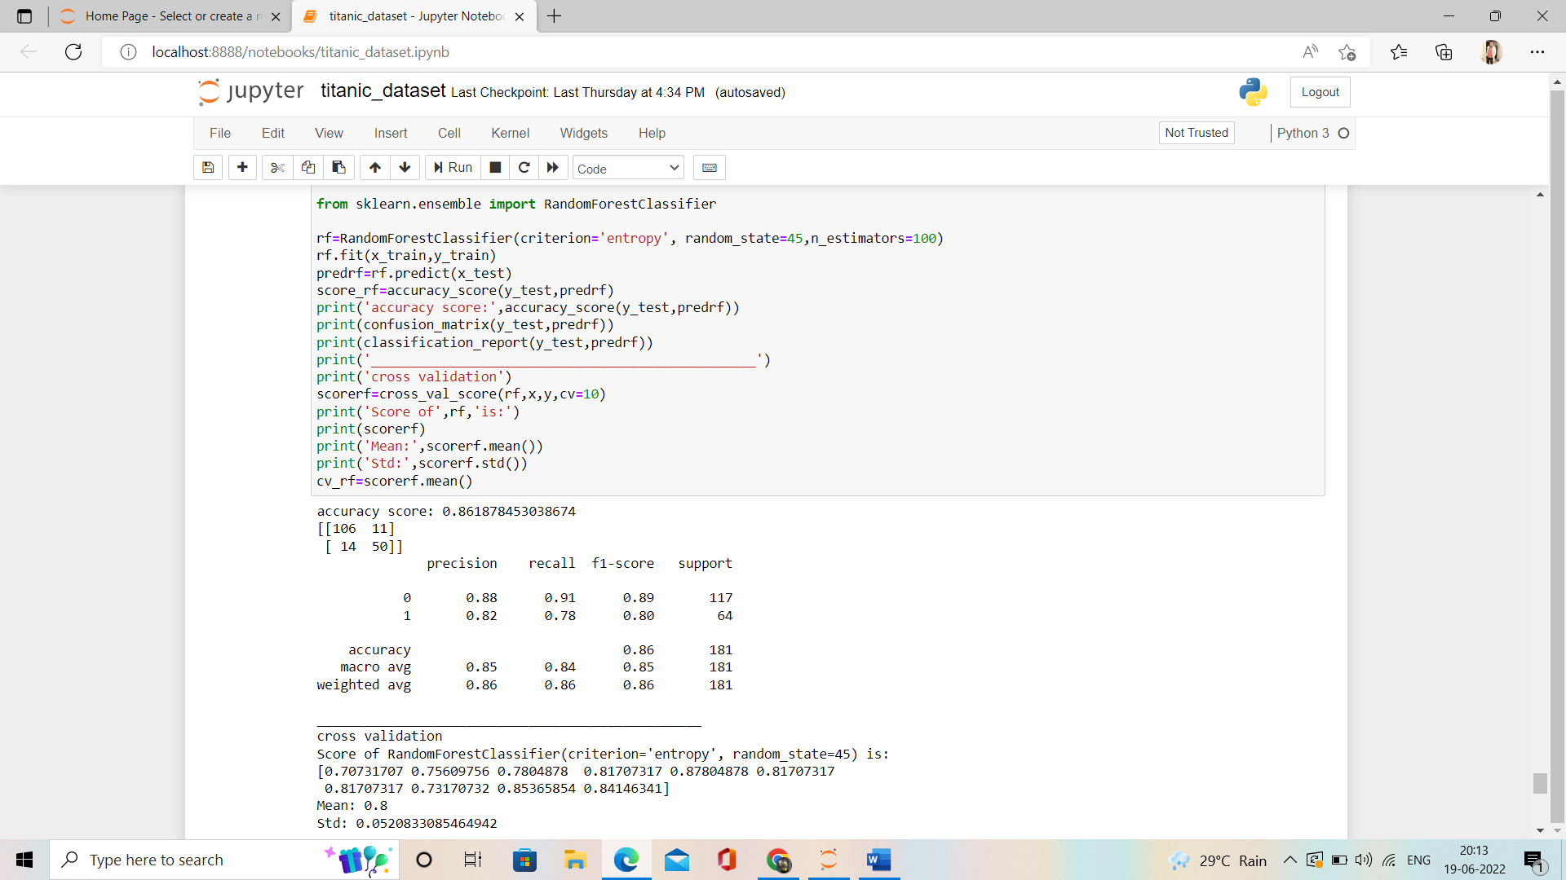

As we can see clearly that **RandomForestClassifier gives us the more accuracy than others hence we will consider it.**

**Drawing the ROC_CURVE:**

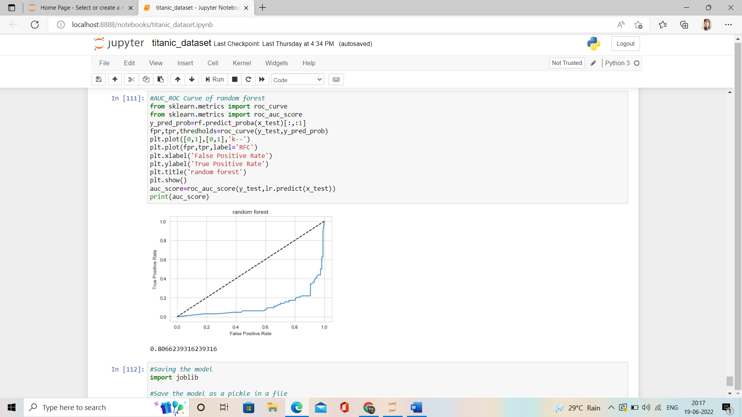

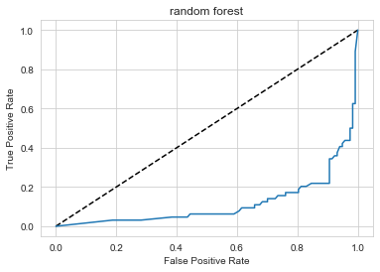

**Saving the Model**

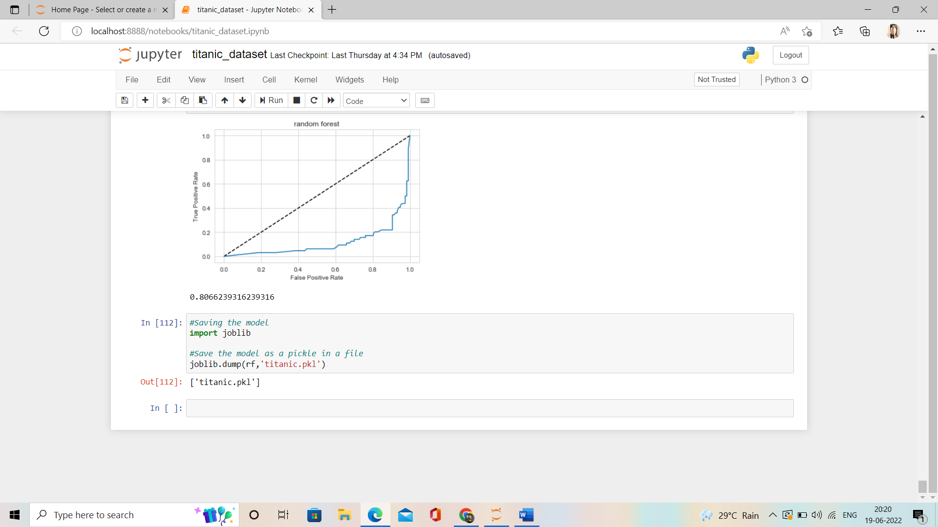

**Conclusion:**

We started with the data exploration where we got a feeling for the dataset, checked about missing data and learned which features are important. During this process we used seaborn and matplotlib to do the visualizations. During the data pre-processing part, we computed missing values, converted features into numeric ones, grouped values into categories and created a few new features. As you can see, we get decent accuracy with all our models, but the best one is **RandomForestClassifier with accuracy 86%.** . And voila, just like that you’ve completed your first data science project! Though there is so much more one can do to get better results, this is more than enough to help you get started and see how you think like a data scientist. I hope this walkthrough helped you, I had a great time doing the project myself and hope you enjoy it too. Cheers!!